**Table of Contents**



**FPT International School**

--- o0o ---

**PROJECT REPORT**

**Gift Shop**

Batch: T1909M

Semester: 1

Group: 5

1. Student-TH1909002 Nguyen Van Thuan
2. Student-TH1908060 Truong Thanh Tu
3. Student-TH1908040 Nguyen Vuong
4. Student-TH1908029 Nguyen Trong Ty

**Hanoi - 02/2020**

1. Problem Definition 3

1.1 Overview 3

i. Introduction 3

ii. Implementation Environment 3

1.2 User Stories 4

Customer 4

i. Log in 4

ii. Register 4

iii. Search by name 4

iv. View the description of each product 4

2. Follow chart 5

2.1 GUI 1: login 5

2.2 GUI 2: Register 6

2.3 GUI 3: search by names 7

2.4 GUI 4: View descripton of each product 8

3. UI\UX 9

3.1 Homepage 9

3.2 Categories 10

3.3 Product details 11

3.4 About us 12

3.5 Contact us 13

3.6 Feedback 14

3.7 Cart 15

3.8 Login 16

3.9 Register 17

3.10 All Brands 18

3.11 Brands Details 19

3.12 All Categories 20

4. Summary 21

# Problem Definition

## Overview

### Introduction

**Requirement Specification:**

The Web site is to be created based on the following requirements.

1. The Home Page should be created making use of Frames with a suitable logo.
2. Home Page should contain details of Gift Items with suitable images.
3. The site should display a menu which will contain the options for brief introduction about the various gift items available, location of the shop and any other information if required.
4. The information about products should be presented in two ways:
   * + - 1. Information should be available category wise, wherein user can click on a particular category and should be able to view all the products related to the category available with complete information. Eg. Category can be “Mugs”, “Cards”, Bracelets” etc. with suitable sub-categories been defined.
         2. Information should be categorized according to the brand names of the products like if a User wants to see only “Hallmark” products or any other company’s products then he/she can click on a Link/button/menu etc and can see only that Brand products.
5. When a user selects any particular brand, a list of products for that brand will be displayed
6. A brief summary of features of individual products should be displayed on the Web Page along with the product but detailed Features should be stored in Individual Word documents which can be downloaded or viewed by the User who wishes to see the same.
7. The user should also be able to compare the various products of different as well as similar brands.
8. There should be a “Contact Us” page which will have the Address of the Company which is as follows and the mail address which when clicked will invoke the local mail client from where they can send an email. Address of the Company should be displayed using GeoLocation API (eg. GoogleMaps).

### Implementation Environment

* Platform
* Windows 10
* Language
* HTML 5
* CSS3
* Javascript
* JQuery
* Bootstrap 3
* Application
* Dreamweaver CS6
* Chrome
* FireFox
* Methodology: Scrum

## User Stories

## Customer

### Search by name

As a customer , i want search the products by their name

### View the description of each product

As a customer , i want contact to admin

### Compare prices

As a customer , i want compare prices with other brands

# Follow chart

## GUI 1: login

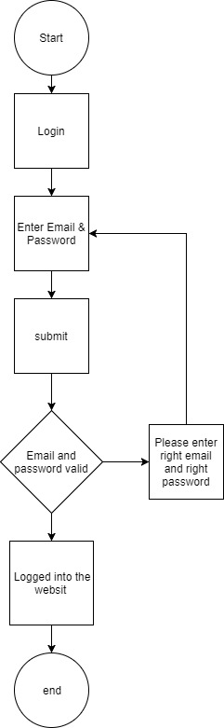

## GUI 2: Register

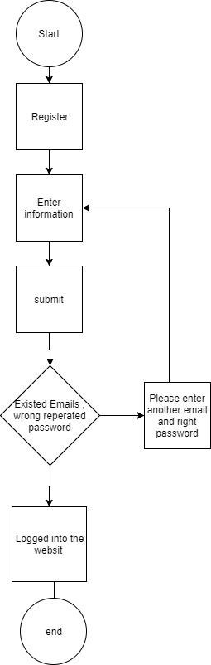

## GUI 3: search by names

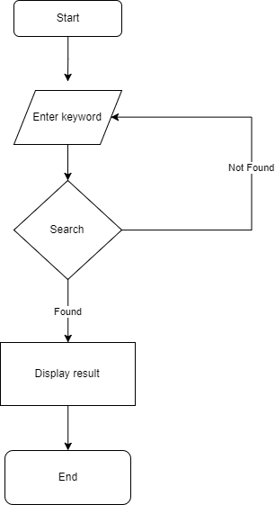

## GUI 4: View descripton of each product

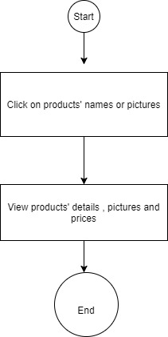

# UI\UX

## Homepage

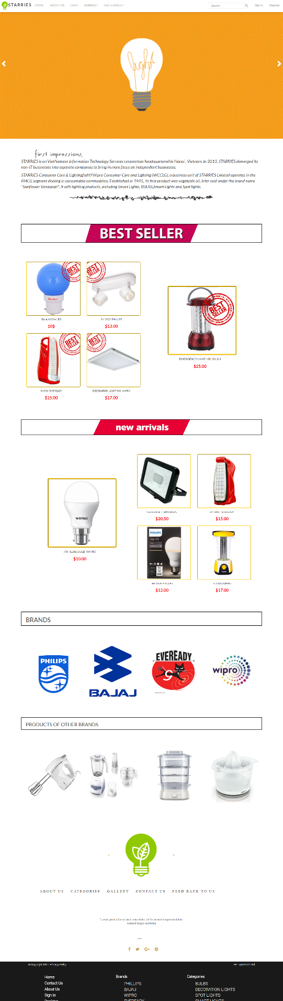

## Categories

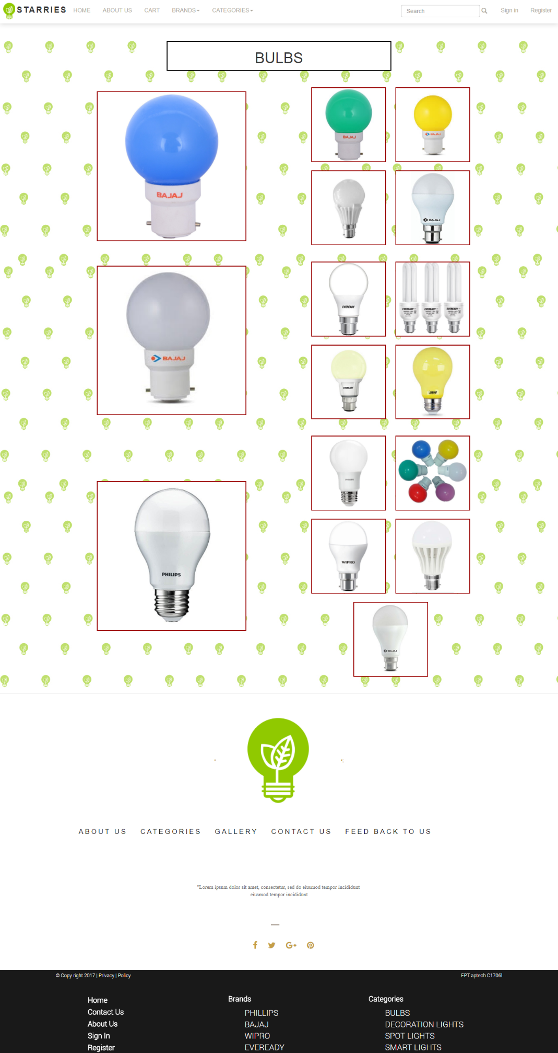

## Product details

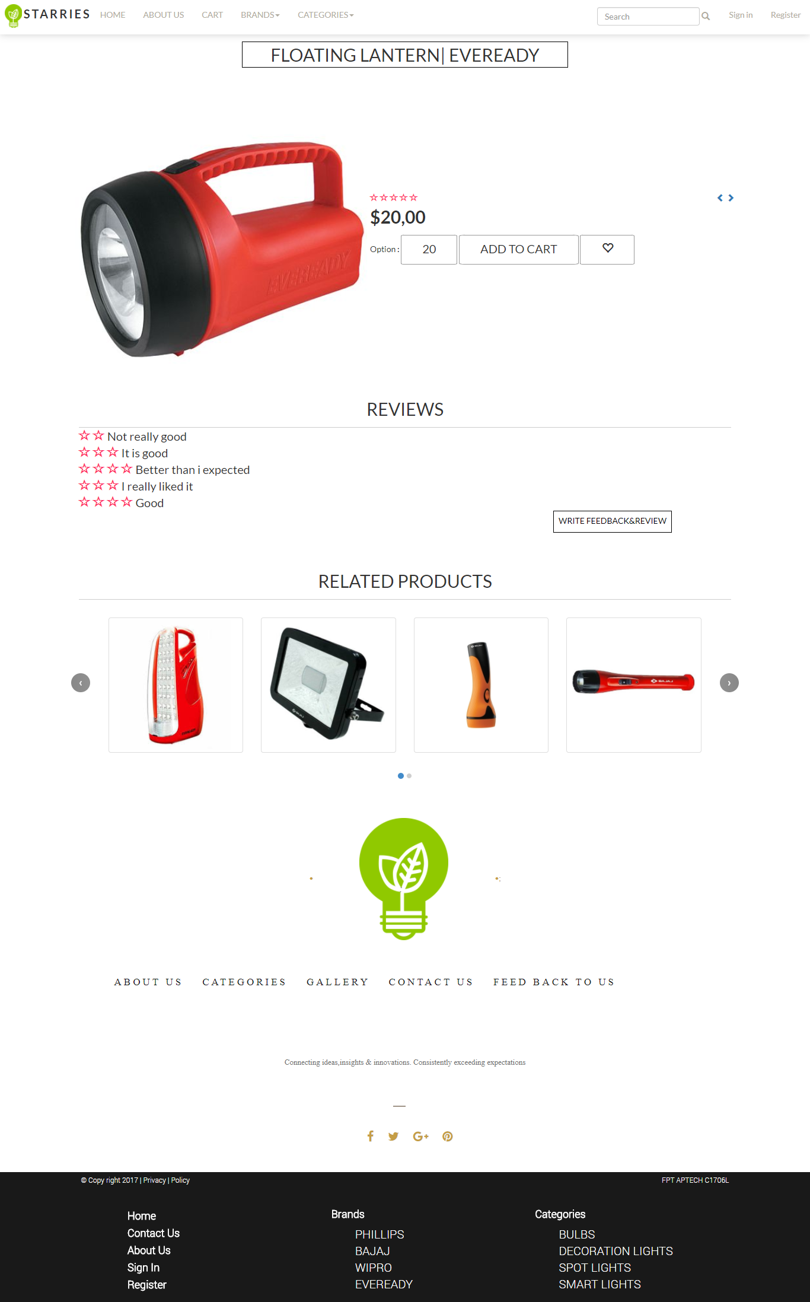

## About us

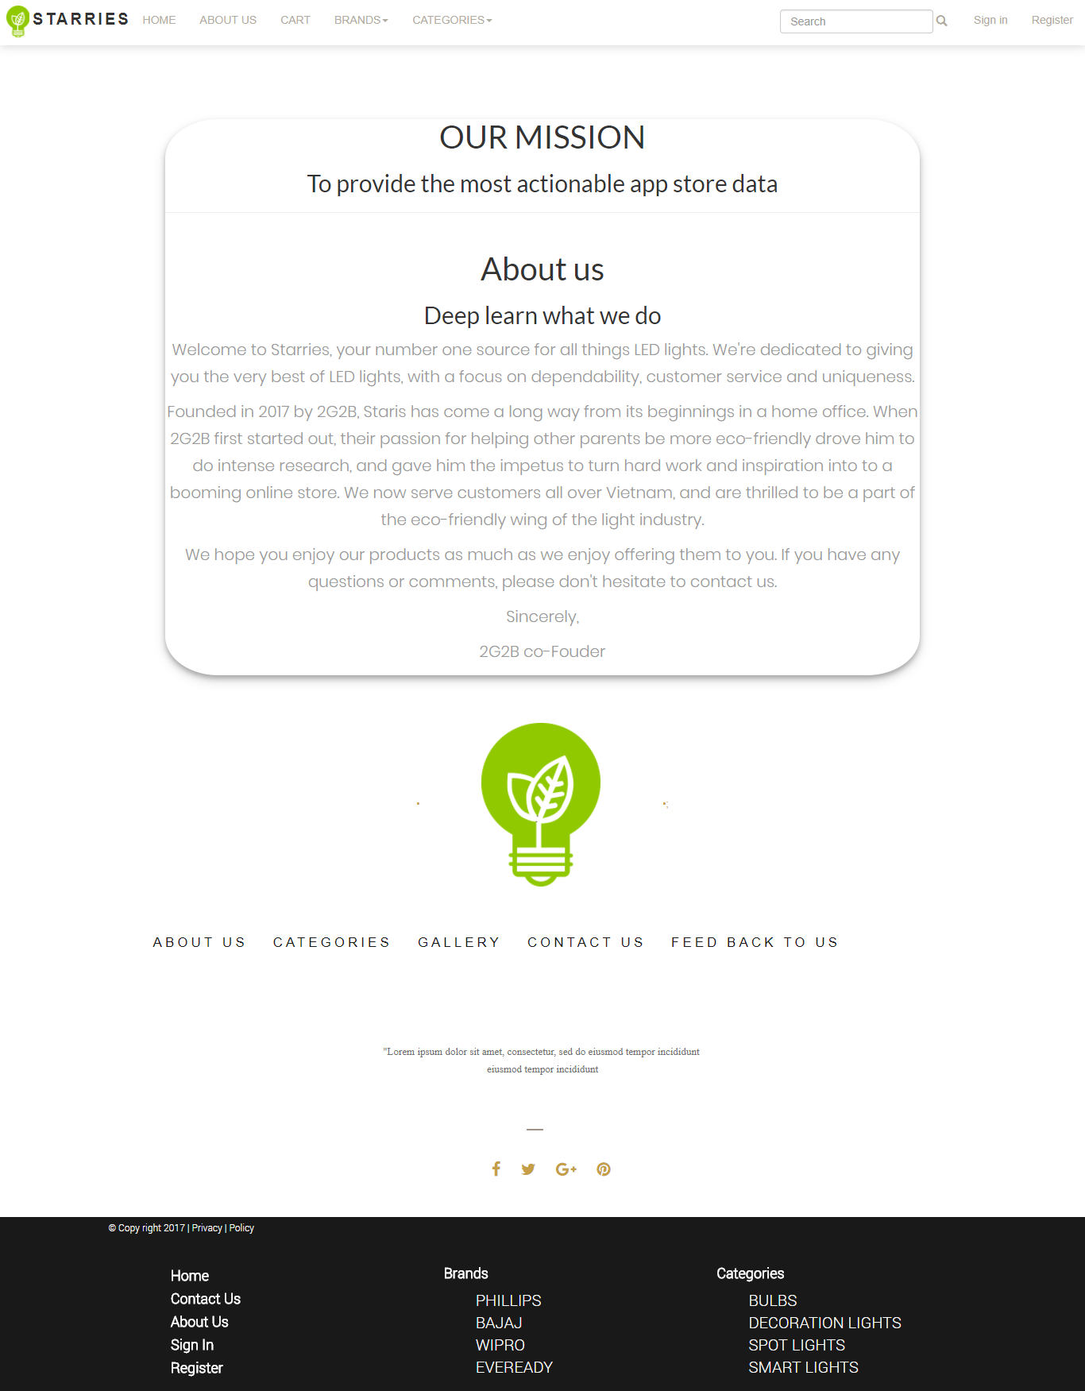

## Contact us

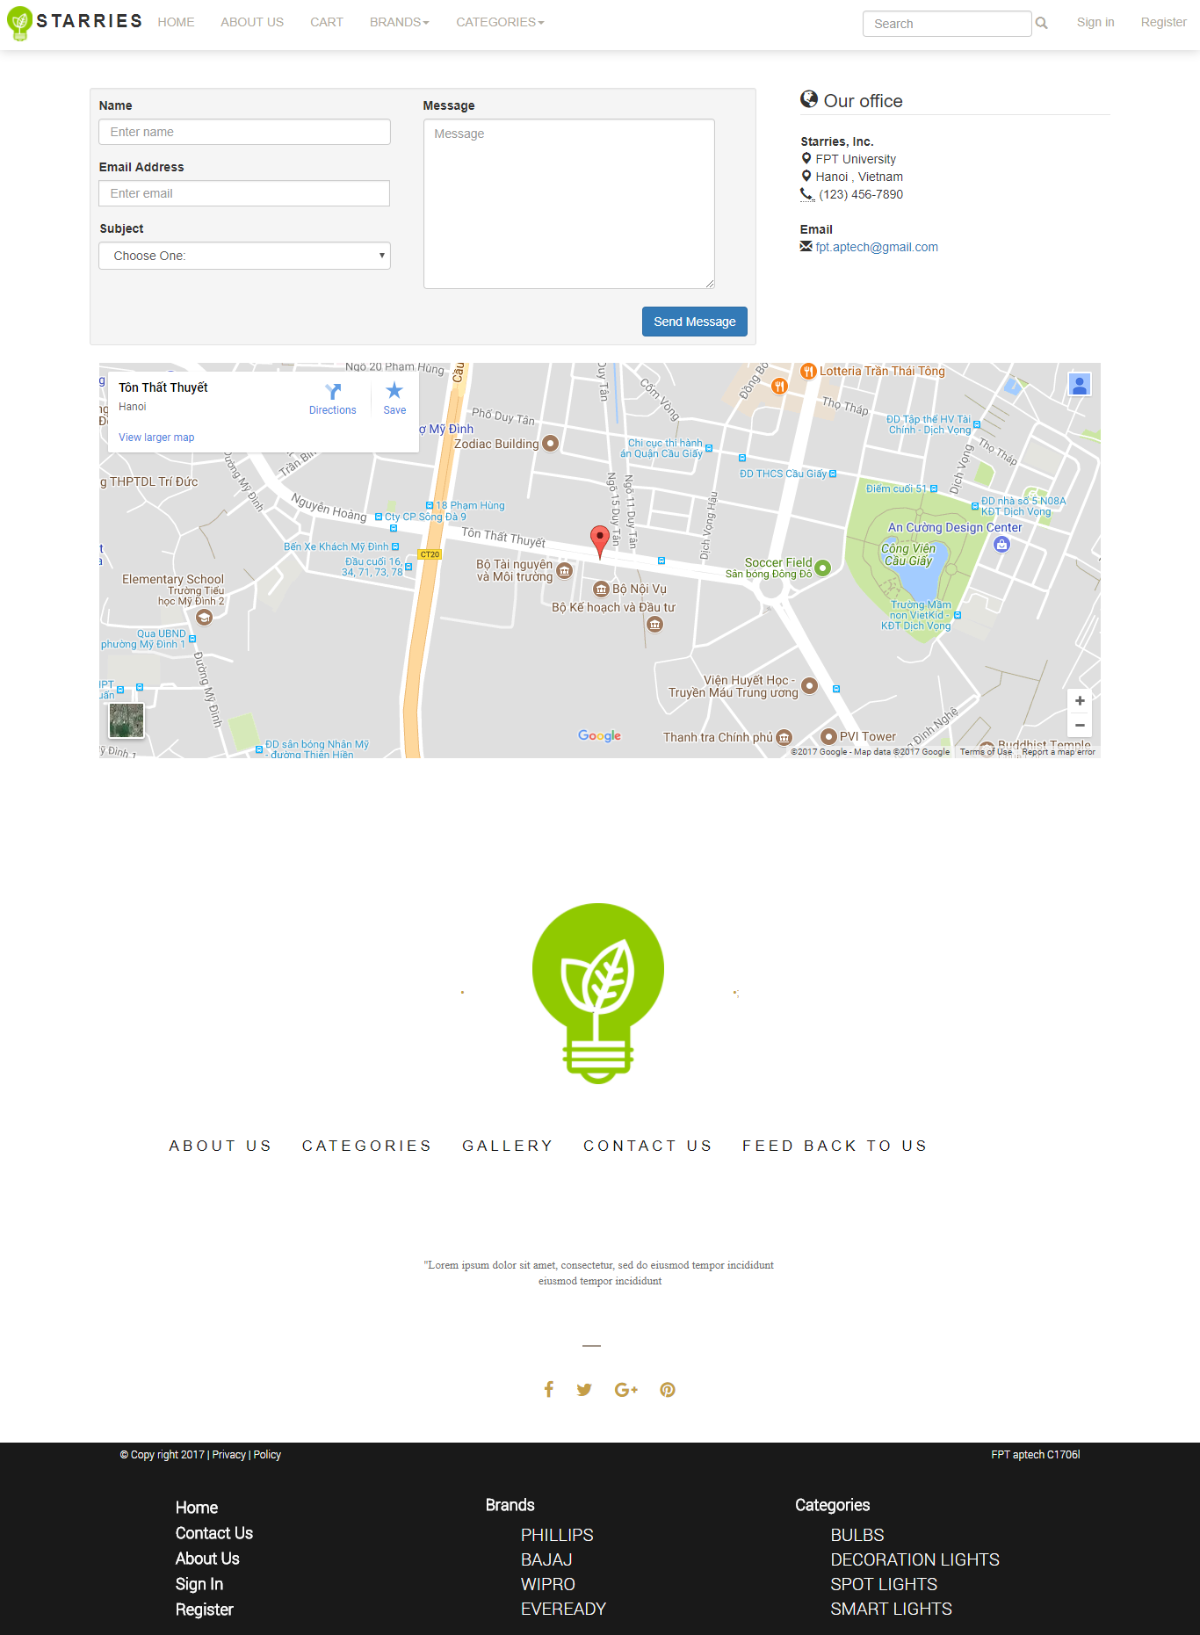

## Feedback

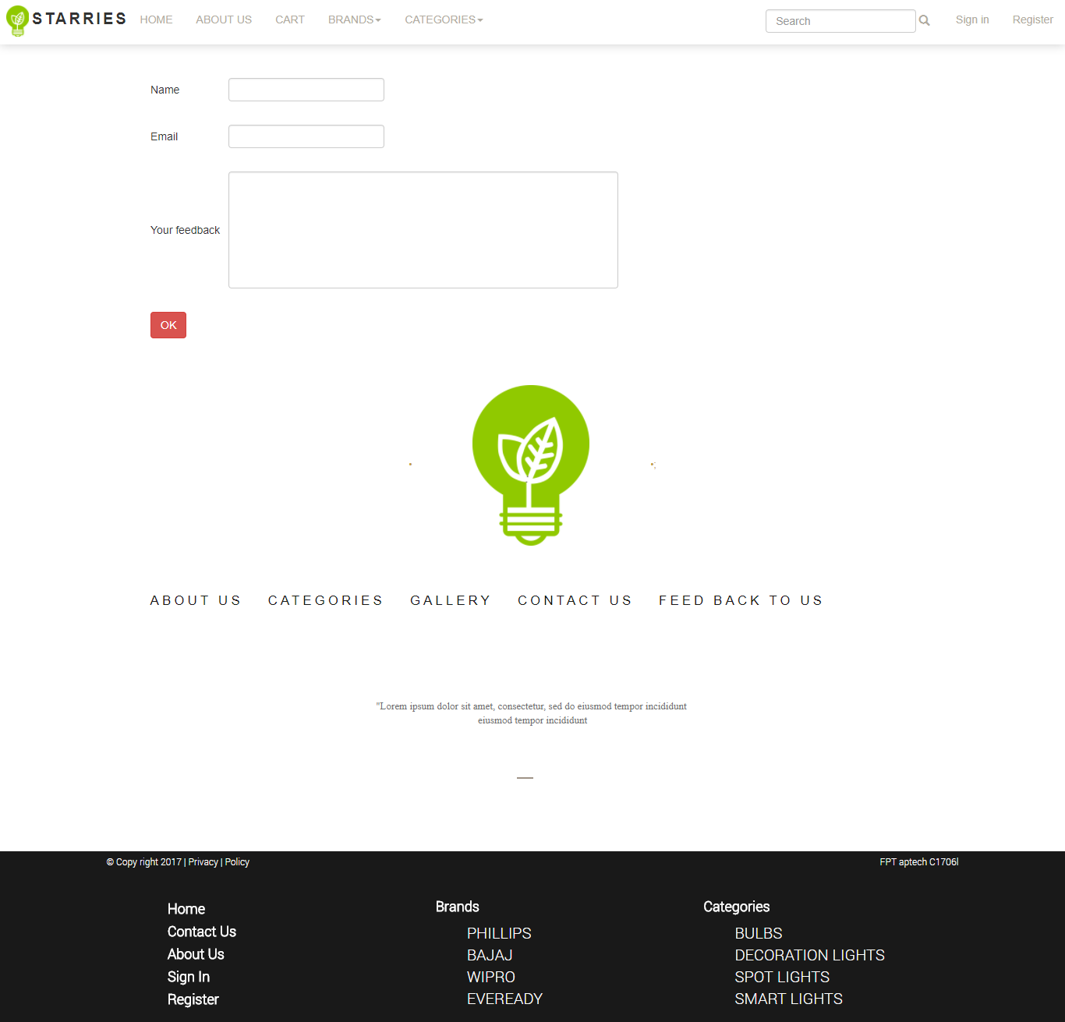

## Cart

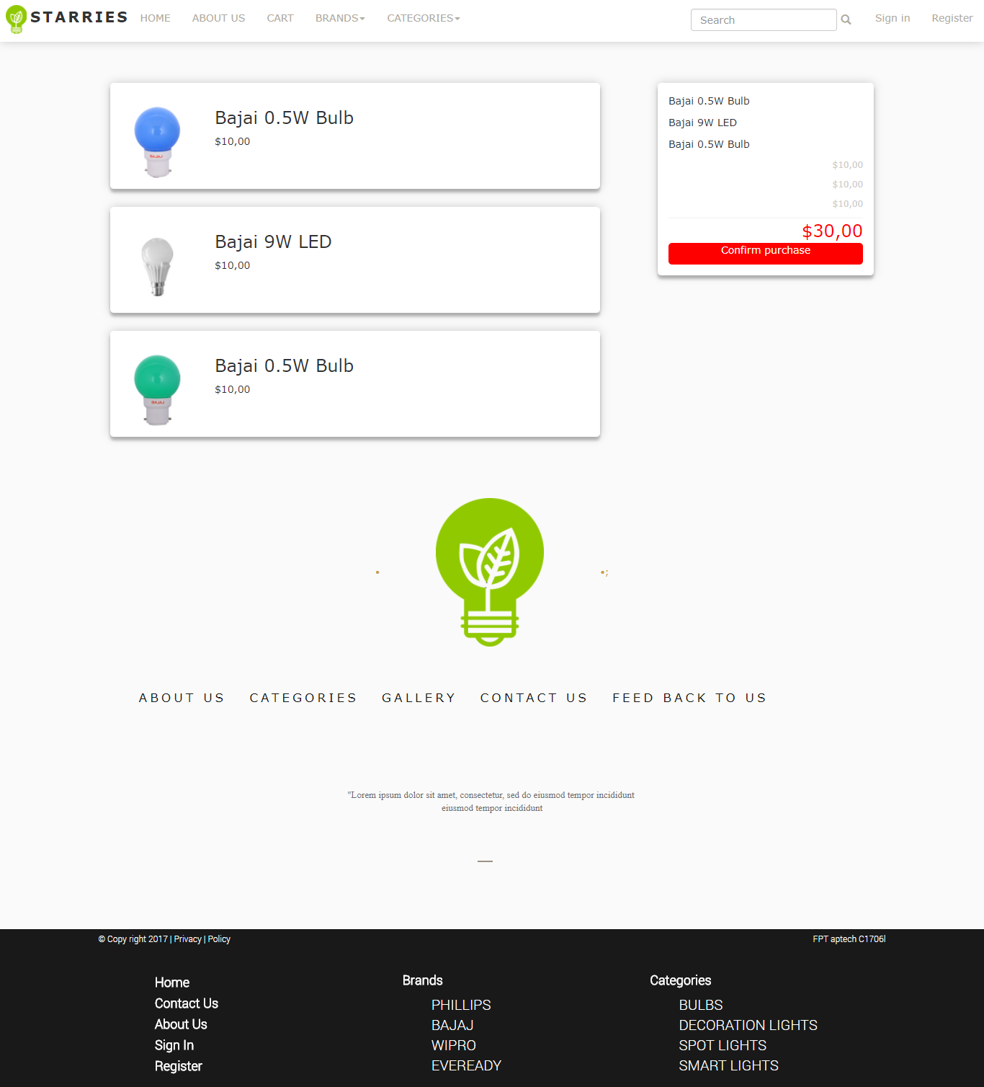

## Login

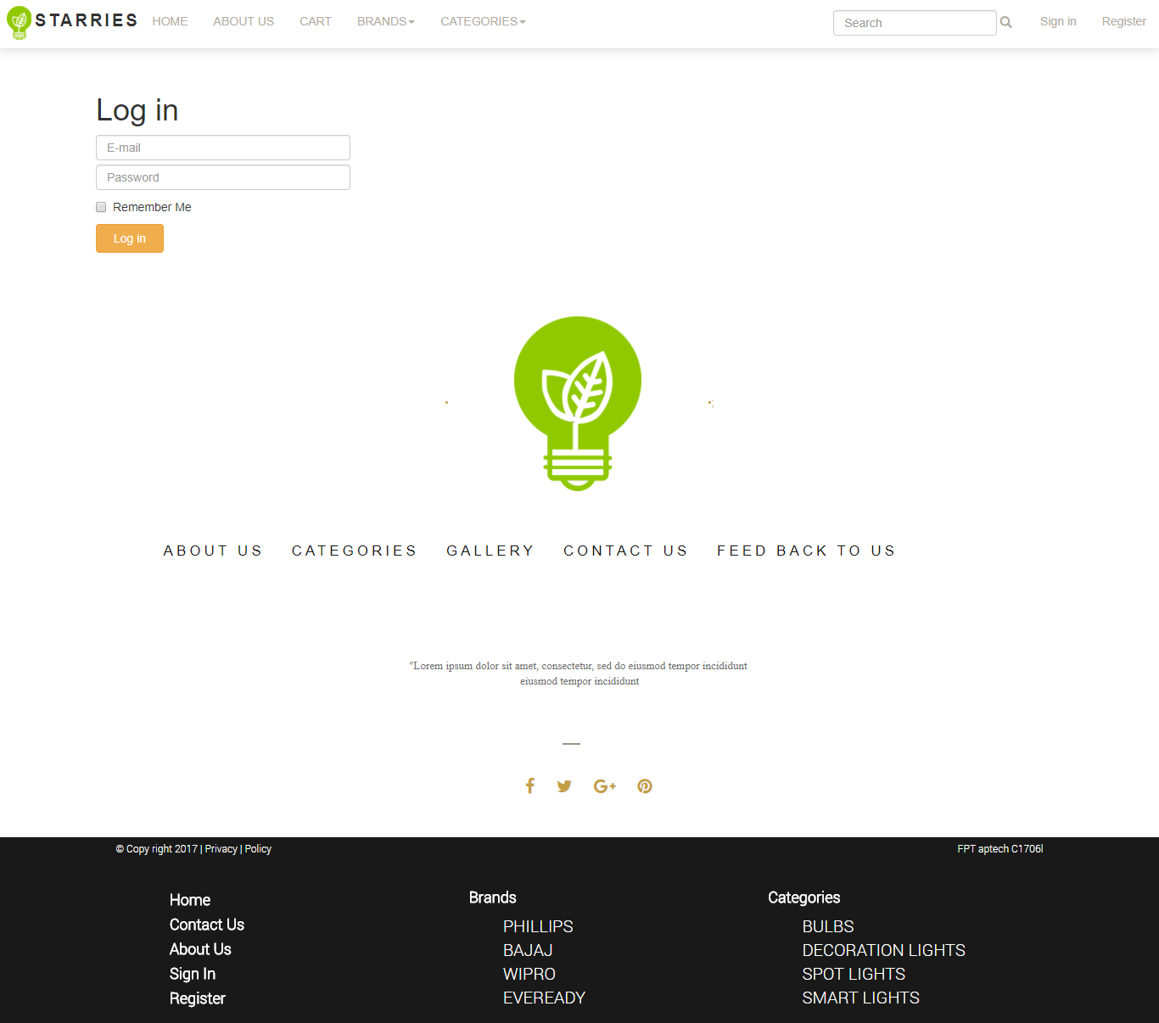

## Register

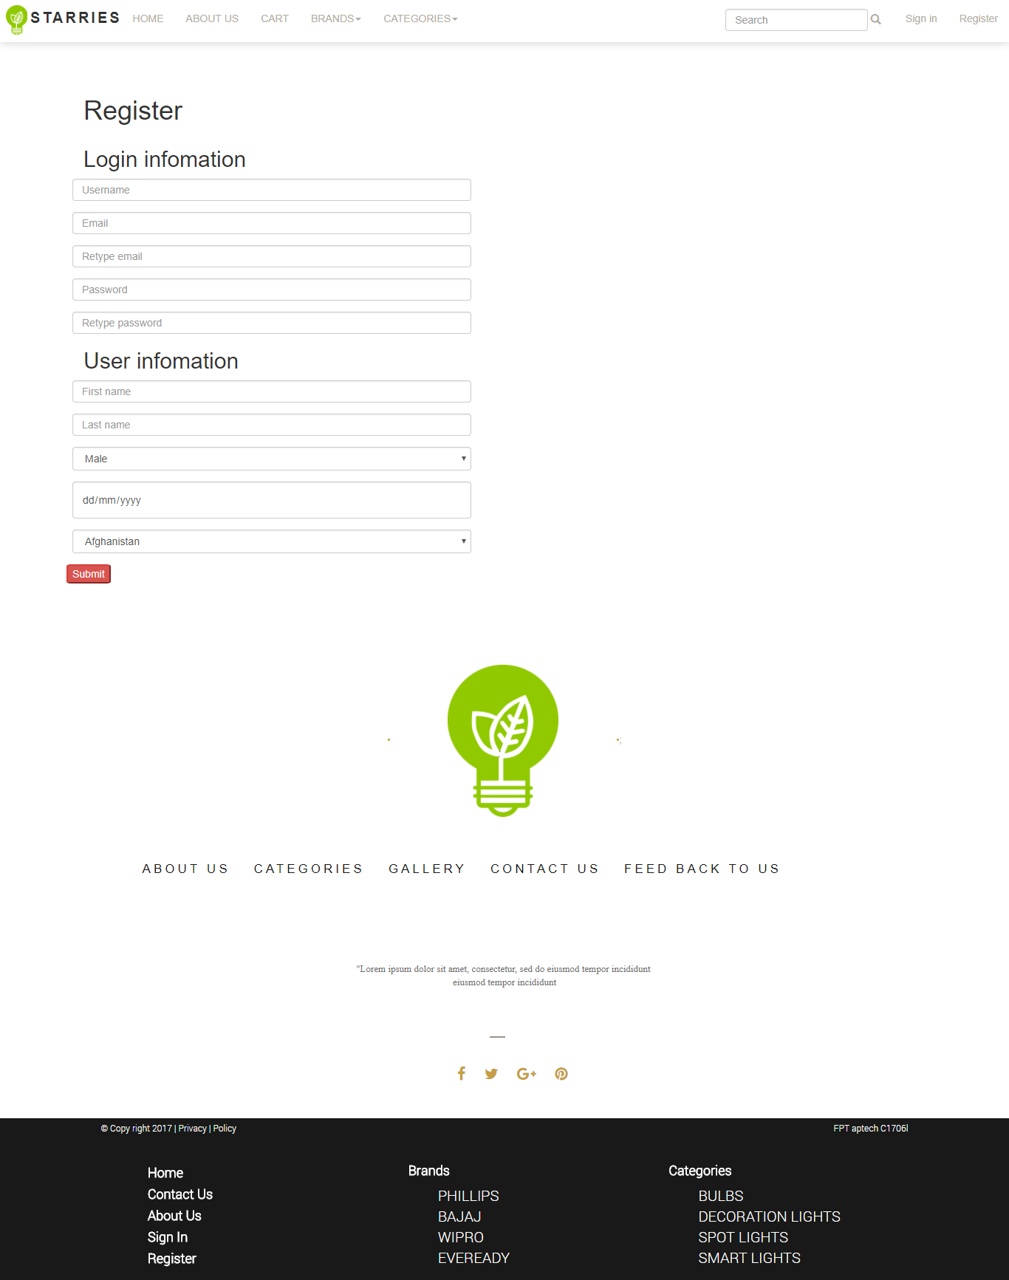

## All Brands

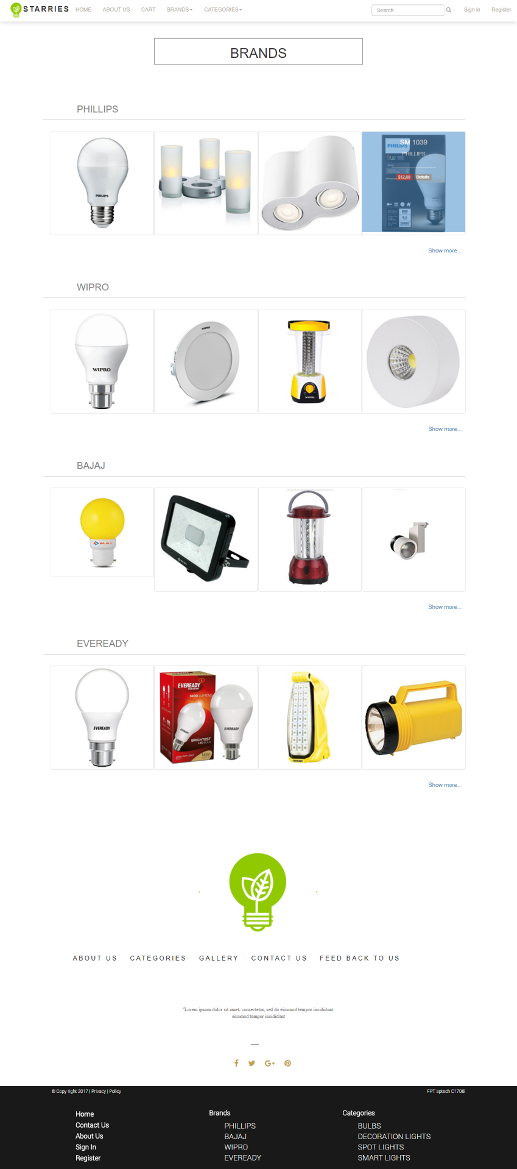

## Brands Details

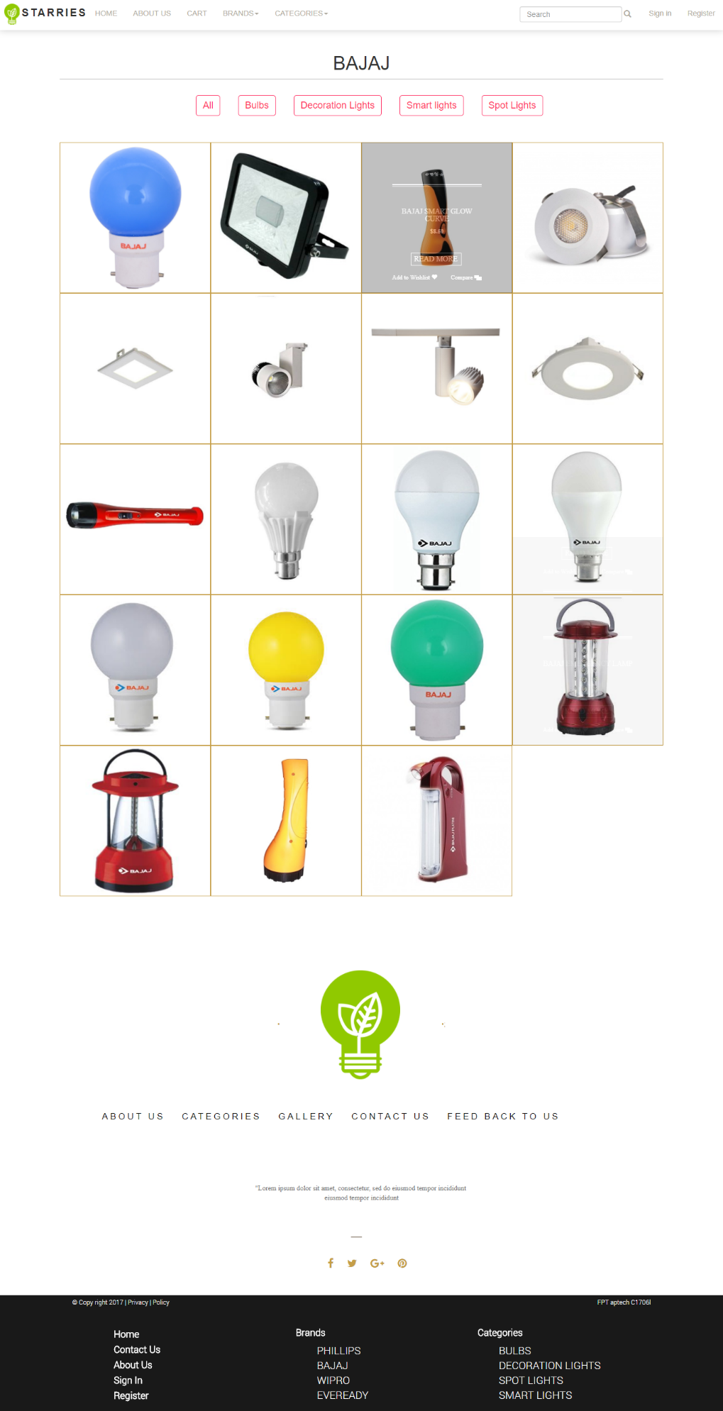

## All Categories

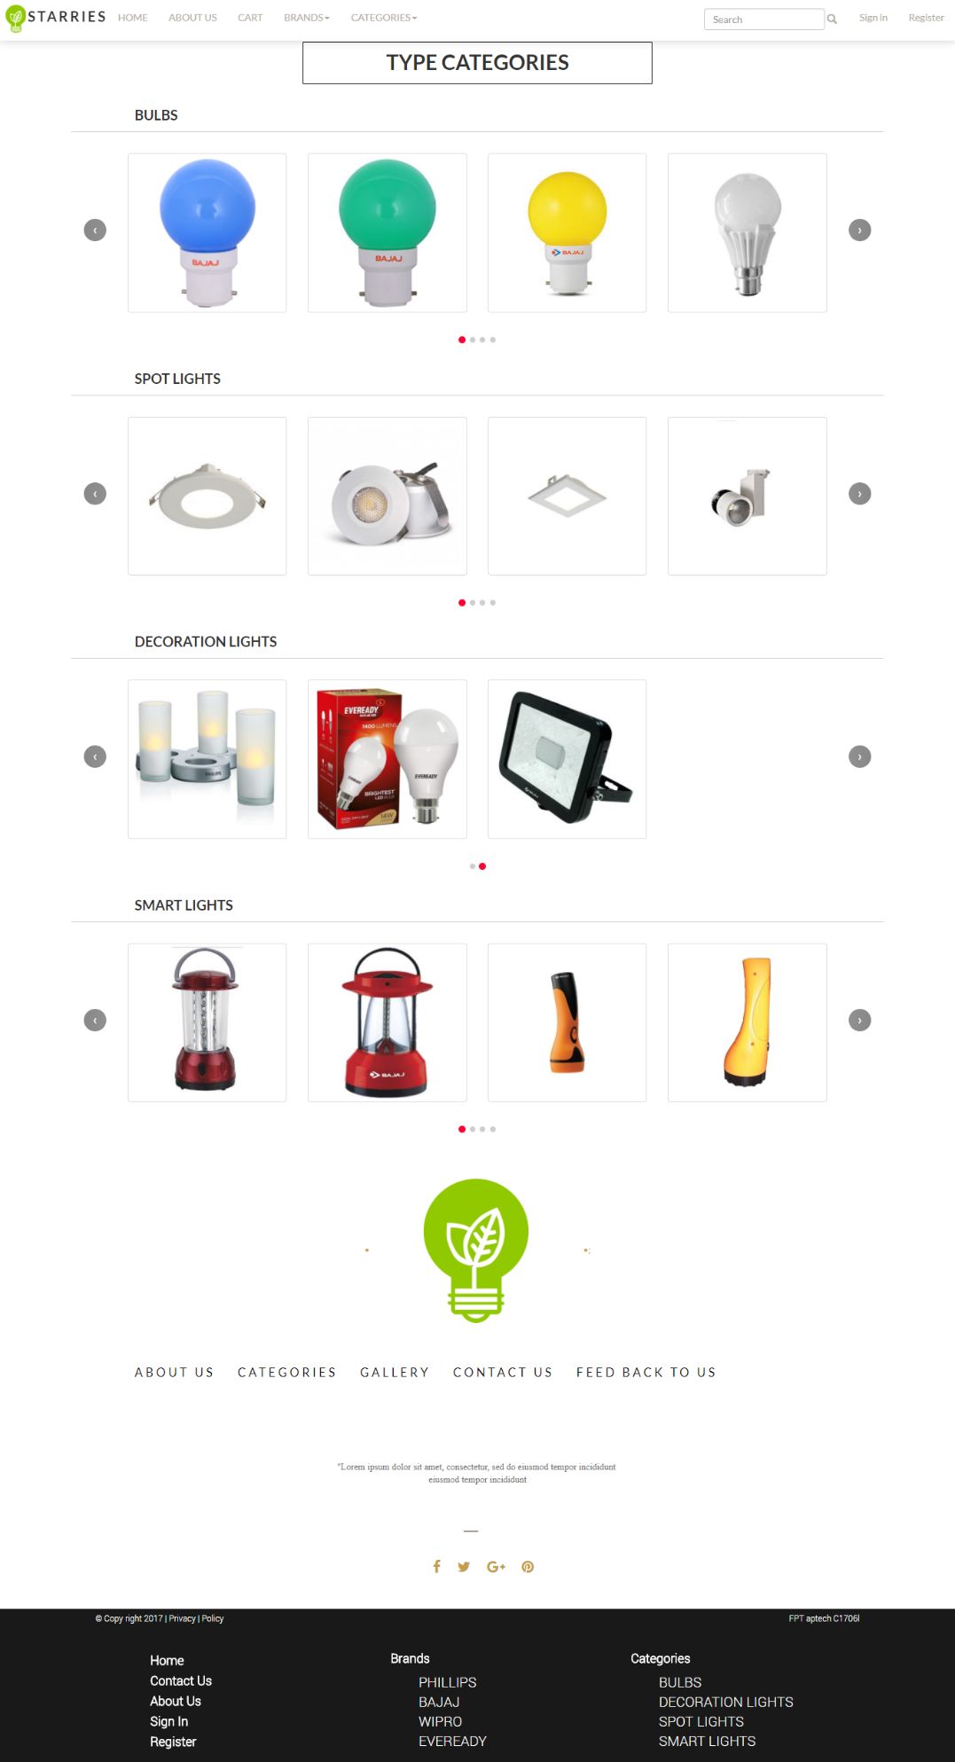

# Summary

The (x) means that person took part in the individual work

For instance : Nguyen Ngoc Thuy did the Homepage and Header ,...

|  |  |  |  |  |
| --- | --- | --- | --- | --- |
|  |  | Nguyen Ngoc Thuy | Nguyen Thu Thao | Nguyen Quoc Anh |
|  | Homepage | x |  |  |
|  | Header | x |  |  |
|  | Find resources: images and information of LEDs | x | x |  |
|  | Logo design |  | x |  |
|  | Login | x |  | x |
|  | Brands Details |  | x |  |
|  | All Brands |  | x |  |
|  | Categories |  | x |  |
|  | All Categories |  | x |  |
|  | Contact us |  | x |  |
|  | About us |  |  | x |
|  | Footer |  | x | x |
|  | Register |  |  | x |
|  | Search | x |  | x |
|  | Product Details |  | x |  |
|  | Merge Code | x | x |  |
|  | Feedback | x |  |  |